Grades 1-5 Registration Form

Child’s Name:___________________________________________
Name preferred to go by_________________________________
Male _________Female__________
Child’s Grade in 2026 – 2027 School Year:_______________
Parent/Guardian’s Name:_______________________________
Address:________________________________________________
Phone________________________

Does child have any dietary concerns?_________________
If, yes, please describe__________________________________
________________________________________________________
Date: (please circle one)
Monday, August 17th

Registration Fee per Child is $15.00.
Amount Enclosed:____________________________

Everyone succeeds during Little School on the Prairie. If your child has any special learning needs, please share this information with our staff. We want to make sure that every child who attends Little School on the Prairie has a fun and rewarding experience.

Since few familes had access to many books or art, the rural school teacher was responsible for teaching the literature and art classics. Each year we use a new theme and curriculum. This year our day and classes will focus on Henry Wadsworth Longfellow’s poem The Midnight Ride of Paul Revere.
Children should wear comfortable clothes that they can play in. Jeans and short sleeved shirts are fine for boys; girls may wear a simple street length dress or a skirt and a shirt. Lunch, in pails, will be provided.

Schedule:
9:10-9:25 Parents drop students off at main
building
9:30 Tour of the Campbell House

10:00 School day begins at Blooming 46
School House
11:25 class picture, lunch in a pail, recess

12:00 Class resumes
1: 50 Parents invited to school for awarding of
one-room school diploma
2:00 School dismissed, parents pick up
students

Parents should feel free to bring a camera and get pictures of their students in the rural school.

Local news media occasionally come to take pictures for the evening news and newspaper. May we allow your child to be photographed? Yes No (please circle one)

WAIVER AND MEDICAL AUTHORIZATION
In consideration of the Grand Forks County Historical Society allowing my child to participate in Little School on the Prairie, which I acknowledge involves some risk of injury. I agree as my child’s parents/guardian to assume all risks, cost, or losses sustained by me, my child, or my child’s family as well as the heirs, executors, administrators, legal representatives, assignees, and successors in interest thereof in connection with his/her participation in Little School on the Prairie.
I give permission to the Grand Forks County Historical Society and /or appropriate medical staff or facility to make whatever emergency (first aid, disaster, evacuation, etc.) measures as judged necessary for the care and protection of my child while under the supervision of the Grand Forks County Historical Society.
In case of medical emergency, I understand that my child will be transported to an appropriate medical facility by the local emergency unit for treatment if the local emergency resources (police, rescue squad) deem it necessary. I understand that the child will be transported at my expense. It is understood that in some medical situations, the staff will need to contact the local emergency resources before the parent, child’s physician, and/or other adult acting on the parent’s behalf.
Because of the danger of possible injury during outdoor activities, I understand the importance of following the staff’s instructions regarding all rules and agree to obey instructions.
Further, I, for myself, my heirs, \executors, administrator, legal representatives, assignees, and successors in interest, hereby release and agree to defend, indemnify and hold harmless the Grand Forks County Historical Society’s employees, Board of Directors, or volunteers (collectively “Releases”0 from any claims, losses or expenses incurred by or on the behalf of me, my child or my child’s family as well as the heirs, executors, administrators, legal representatives, assignees, and successors in interest thereof INCLUDING CLAIMS ARISING FROM THE RELEASEES OWN NEGLIGENCE.

Signature:____________________________________Date___________ (please circle one) Mother Father Guardian

Grand Forks County Historical Society’s

Little School on the Prairie

Come and experience rural education in the one room school as it was during the 1930’s.

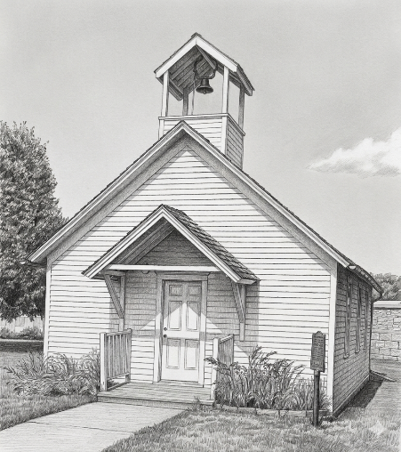

Wednesday, August 19th, 2026

Grand Forks County Historical Society
2405 Belmont Road.
Grand Forks, ND 58201.
701-775-2216

